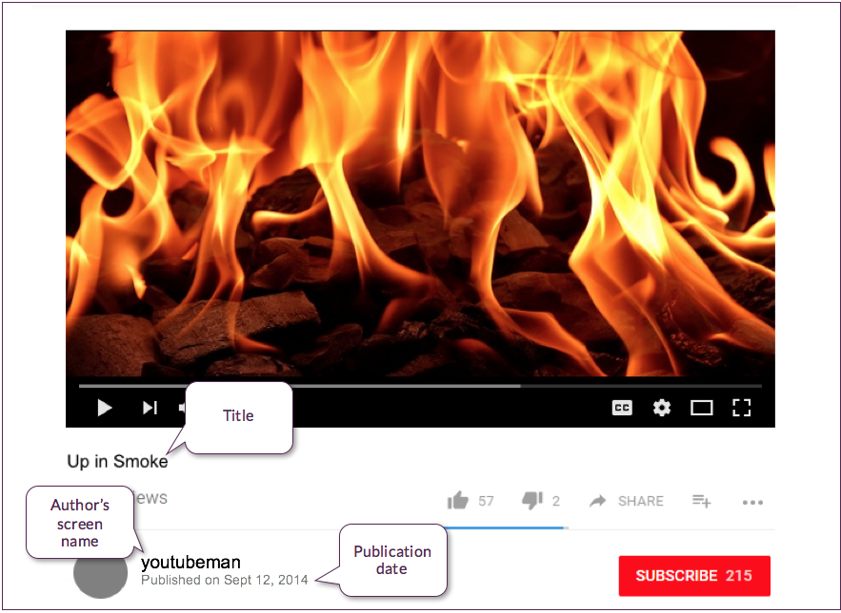

https://www.youtube.com/12345

YouTube

**Source is fictional**